# **Department of Computer Science and Engineering Islamic University of Technology (IUT)** A subsidiary organ of OIC

# **Laboratory Report**

# CSE 4412: Data Communication and Networking Lab

## 

|  |  |
| --- | --- |
| **Name** | **: Chowdhury Ashfaq** |
| **Student ID** | **: 200042123** |
| **Section** | **: A** |
| **Semester** | **: Winter** |
| **Academic Year** | **: 2023** |
| **Date** | **:16/01/23** |
| **Lab No** | **: 2** |

### 

### **Title:** Understanding the basics of OSI Model

### **Objective**:

1. Examine HTTP Web Traffic
2. Display Elements of the TCP/IP Protocol Suite

### **Devices/ software Used**: Cisco Packet Tracer, Virtual Web

### **Working Procedure:**

* After setting up Cisco Packet Tracer I used it to create a network topology that simulates the scenario I wanted to examine. The requirements and the procedure of the lab was given in the .pka file. As a requirement I configured the built-in web server feature in Cisco Packet Tracer.
* Following the setps I started the simulation and began capturing network traffic.
* Then I examined how the different layers of the OSI model were interacting with each other.I also examined web traffic which enables us to understand the way client and server communicates.
* Lastly, I analyzed the procedure and the data captured by Cisco Packet Tracer. I gathered my findings to understand the OSI Model.

### **Diagram of the experiment:**

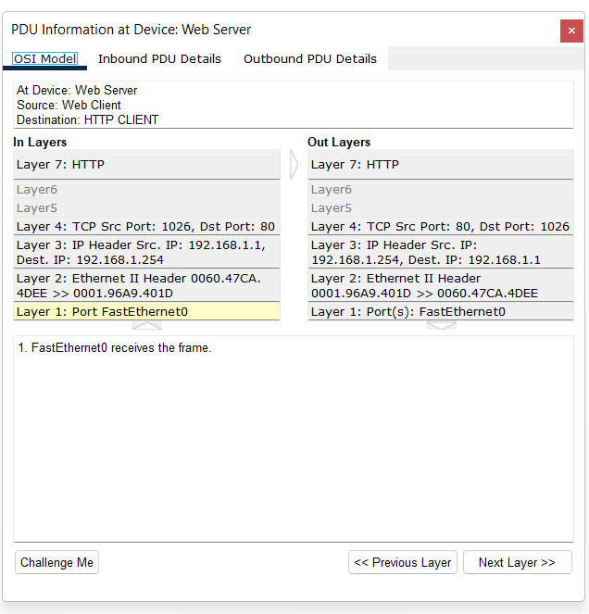

### **Observation**:

The OSI model can be understood through the simulation as it shows data sent across each network layer. A data content is broken down in many parts for easy sending each of which is identified by a unique code called PDU. All of the events and PDU of every layer can be watched in the simulation mode.

### **Challenges:**

* First of all using Cisco Packet Tracer for the first time was very hard.
* Understanding the OSI model took a lot of time.